#### **Time series forecasting with the decomposition technique**

**DOES THE DATA HAVE A TREND? DOES IT HAVE A SEASONAL COMPONENT?**

Yes, The data shows a clear trend of increasing airline passengers between 1949 and 1959, with a visible annual increase. In addition, there is a clear seasonal trend showing peaks during summers and troughs during winters, following a cyclical trend every year.

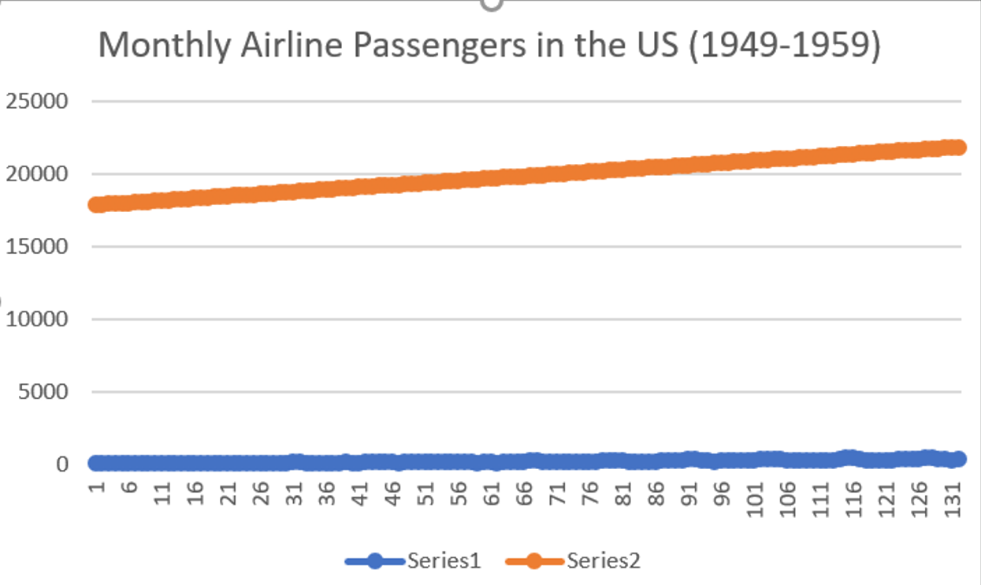

**Figure 1. Monthly Airline Passengers in the US (1949–1959):**

#### **HOW MANY SEASONS CAN BE RECOGNISED IN THIS DATA SET?**

There are 12 different seasons within a year, each one corresponding directly with a particular month, because each month equally has typical seasonal features.

#### **CALCULATE APPROPRIATE MOVING AVERAGES TO SMOOTH THE TREND. CALCULATE AND INTERPRET THE SEASONAL COMPONENTS.**

I calculated a 12-month moving average to smooth out the trend and centered it for better alignment. Then, I calculated the seasonal ratios (actual ÷ centered MA) for each month and averaged these ratios by month to determine the seasonal indices. High indices (e.g., July, 1.31) shows peak season, while low indices (e.g., November, 0.85) shows the off-season.

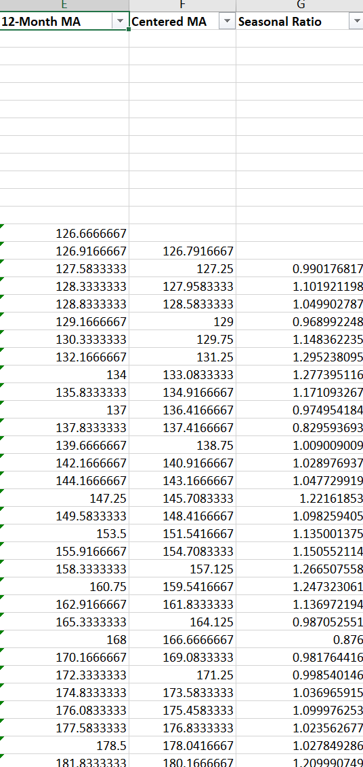

***Figure 2. Sample calculation of 12-Month Moving Average, Centered Moving Average, and Seasonal Ratio for the airline passenger dataset (first 20 months shown).***

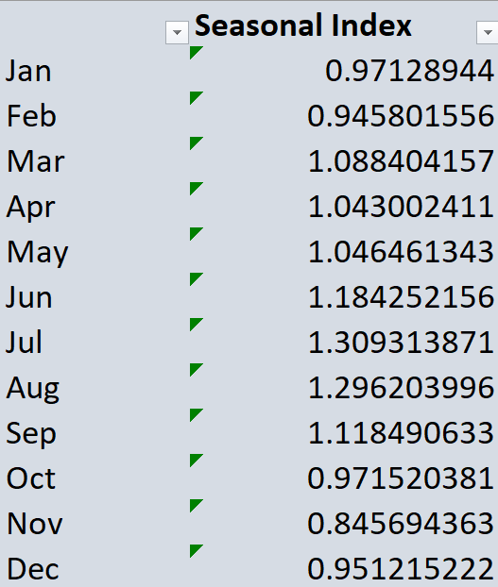

**Figure 3. Monthly Seasonal Indices:**Seasonal indices for each month, showing the multiplicative seasonal factors used in forecasting.

#### **WHICH MODEL FITS THE DATA BEST – ADDITIVE OR MULTIPLICATIVE? WHY?**

The multiplicative model is most appropriate because the seasonal variation increases as the trend increases (the peaks and troughs get larger as passenger numbers grow).

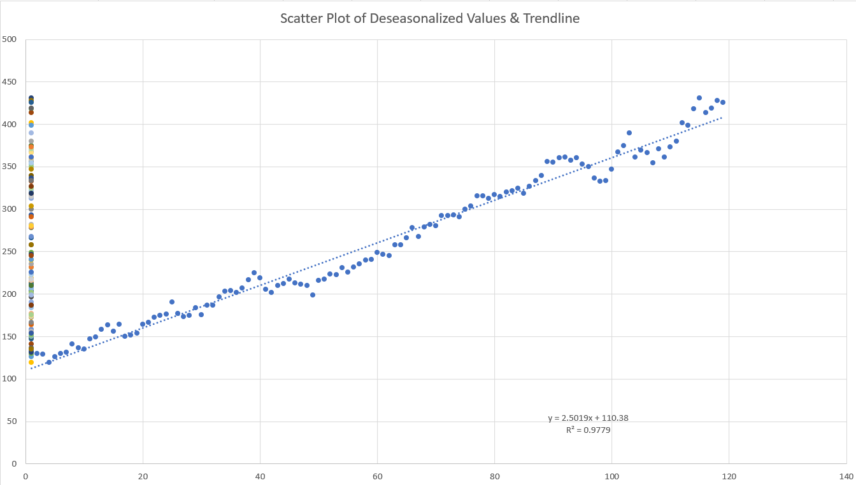**Figure 4. Trendline Fit to Deseasonalised Data:**  
Scatter plot of deseasonalised monthly passenger numbers (Y-axis) versus time period (X-axis), with fitted linear trendline. The high R² value indicates a strong trend component.

**FORECAST THE NUMBER OF AIRLINE PASSENGERS FOR 1960 USING PREVIOUS YEARS’ DATA.**

Each month of the year 1960 had the deseasonalized linear trend applied to it and then multiplied by the respective seasonal index to produce the forecast for all the months.

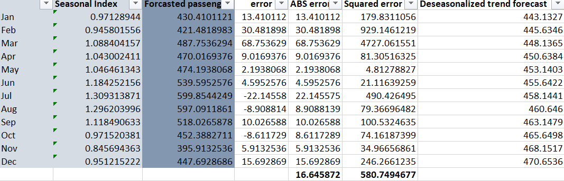

**Figure 5. Forecasts for 1960 and Model Error Calculation:**  
Table showing forecasted passengers for 1960, comparison to actual data, and error metrics (MAE, MSE).

**CALCULATE THE MAE AND MSE FOR YOUR FORECASTS.**

#### 

In comparing projected values with actual values of passengers during the year 1960, I calculated mean absolute error (MAE) as 16.65 and mean squared error (MSE) as 580.75, thus suggesting the model matches the data very closely.